E-Bazaar Vision

Version 1.0

Revision History
Table | Version | Description | Author
2/May/17 | Draft | Initial Draft | Kokeb Beyene
2/May/17 | 1.0 | Minor revisions following Peer Review.  Added performance requirements. | Belisty
2/May/17 | 1.0 |  | Binyam
2/May/17 | 1.0 |  | Segne

Table of Contents
1 Introduction
1.1 Purpose
1.2 Scope

2 Positioning
2.1 Business Opportunity
2.2 Problem Statement
2.3 Product Position Statement
3 Stakeholder and User Descriptions
3.1 Market Demographics
3.2 Stakeholder Summary
3.3 User Environment

3.8 Alternatives and Competition
4 Product Overview
4.1 Product Perspective
4.2 Summary of Capabilities
4.3 Assumptions and Dependencies

5 Other Product Requirements

Vision

1 Introduction

1.1 Purpose
The purpose of this document is to define the high-level requirements of the E-Bazaar Online Shopping system in terms of the needs of the end users.

1.2 Scope
This Vision Document applies to theWith the advent of e-business solutions and the creation of dotcom companies, the management of e-Bazaar, Inc., has initiated an enterprise-wide project which aims at rewriting its current client-server order-entry system. The IT department will develop this client-server system to interface with the existing course catalog database.
The original 2-tiered system was developed quickly as a way to assist sales reps in taking telephone orders. However, now there is a need for this in-house order entry system to be extended to the web to enable online shopping.

1.3 Definitions, Acronyms and Abbreviations
See the Glossary [5].

2 Positioning

2.1 Business Opportunity
This project of , the new system will function making online purchase both on the Internet (online customers) and on an Intranet (for sales representatives) . The product management department will need to define new products and categorize them into catalogs of various types: books, CDs, computer hardware, software, women’s clothing, men’s clothing, exotic sports goods and state-of-the-art gadgetry.

2.2 Problem Statement
The problem of | E-bazaar is facing various business and market challenges that make it necessary for e-Bazaar companies to rebuild their business systems. The architecture and design of the system were not meant to sustain the current load
affects | Customers, Sales reps, and E-Bazaar Management inc.
The impact of which is | Gradual piecemeal additions to functionality have introduced unexpected errors and system failures have become more frequent
A successful solution would | Speed up and Handle current load of the company, the new system will make online purchase function both on the Internet (online customers) and on an Intranet (for sales representatives)

2.3 Product Position Statement
For | E-bazaar ILC companies Customers, Sales reps, and the Management.
Who | Purchase, browse, review history of past orders
The Online Shopping | Is a tool
That | Making online purchase and function both on the Internet (online customers) and on an Intranet (for sales representatives)
Unlike | The existing outdated in-house /phone call/ order entry system
Our product | Provide customers be able to make online purchases, browse online catalogs of products of various types (both catalogs and products), review a history of past orders, and conduct online shopping with a shopping cart, which can be used for immediate online purchase and also can be saved and reviewed and updated later by the user.

3 Stakeholder and User Descriptions
This section describes the users of the E-bazaar inc e-Bazzar System. There are 3 types of users of the E-bazaar System; the Customer, the Sale reps, and the Managements.

3.1 Stakeholder Summary
Name | Represents | Role
Chief Information Officer | IT Department and E-Bazaar INC as whole. | Responsible for project funding approval. Monitors project progress.
legal department |  | before an order is accepted, the customer needs to formally acknowledge the standard Terms of Agreement that e-Bazaar has with its customers
Product Management Department | The Sales representative, Product Management Department | define new products and categorize them into catalogs of various types: books, CDs, computer hardware, software, women’s clothing, men’s clothing, exotic sports goods and state-of-the-art gadgetry.
Customers | Customers | register their names and information, including billing and shipping addresses, method of payment and default catalogs as part of their profile
Pigeons, Inc | Carrier | guaranteed that customers who make purchases at e-Bazaar get the highest-quality and lowest prices on shipping of their products
external credit verification system | Vender | used to verify credit card processing
external vendor | Vender | has agreed to supply an external Rules Engine, including an Address Sanitizer, that will be used to store and execute rules for data validation and to format address data according to published post office standards.
WhereAreYou?, Inc | Internet portal | whereby a large volume of on-line customers will be added to their already growing clientele.

3.2 User Environment
The University User Community is a large sophisticated community that demands the flexibility and response time that an on-line course registration can provide.
The users are educated, computer literate, and in most cases own personal computers in their homes. The ability to register for courses via personal computers and to review their grades on-line would greatly streamline course registration.
The initial release of C-Registration will be limited to Wylie College. Marketing subsequent releases to schools, colleges, and universities is under consideration by the Wylie IT Department. As a result, Course Registration will be designed to be expandable and all user community data (i.e. College Name) will be table driven and easily modifiable upon system installation.

3.3 Alternatives and Competition
The user community was unaware of any viable alternatives or off-the-shelf solutions. The user community supported the strategy that the system should be developed internally by the College in order to reduce costs, ensure appropriate functionality, and to guarantee continued support and maintenance on the system.

4 Product Overview
This section provides a high level view of the e-Bazaar System capabilities, interfaces to the external shipping System and product Catalog Data Base System, and the system configuration.

4.1 Product Perspective
Current customers can register their names and information, including billing and shipping addresses, method of payment and default catalogs as part of their profile, which should be loaded at login. This is in accordance with the Personalization metaphor, where a Customer can filter the defaults they see by way of defining their preferences in a Customer Profile that gets dynamically loaded upon login. In this first phase of development, the new application will not support the creation of new customers.

Figure 4.1 Online -shopping system

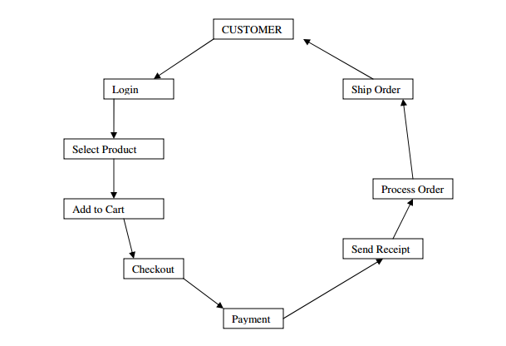

Figure 6.1.2 C-Registration System Overview

4.3 Assumptions and Dependencies
The following assumptions and dependencies relate to the capabilities of the C-Registration System as outlined in this Vision Document:
o The existing Billing and Course Catalog Database Systems which reside on the College DEC VAX Mainframe will continue to be supported until at least 2005.
o The external interfaces of the Billing and Course Catalog Database Systems are as defined in [2] and [3] and will not be altered.
o It is assumed that the College will continue to operate and support the existing UNIX Server and the DEC VAX Mainframe until at least 2005.
o It is assumed that additional funding will be available by 2005 to replace the legacy Billing and Course Catalog Database Systems.
o Implementation of the new registration system in time for the January 2000 school term is dependent upon funding approval by March 1st, 1999.

5 Other Product Requirements

5.1 Applicable Standards
The desktop user-interface shall be Windows 95/98 compliant.

